**VISUALIZATION TOOL FOR ELECTRIC VEHICLE CHARGE AND RANGE ANALYSIS**

* **INTRODUCTION**
* **OVERVIEW**

*A vehicle that can be powered by an electric motor that draws electricity from a battery and is capable of being charged from an external source and have an electric motor instead of an internal combustion engine.*

*The Electric Vehicle (EV) is not new, but it has been receiving significantly more attention in recent years. Advances in both EV analytics and battery technologies have led to increased automotive market share. However, this growth is not attributed to hardware alone. The modern mechatronic vehicle marries electrical storage and propulsion systems with electronic sensors, controls, and actuators, integrated closely with software, secure data transfer, and data analysis, to form a comprehensive transportation solution. Advances in all these areas have contributed to the overall rise of EV’s, but the common thread that runs through all these elements is data analytics*.

* **PURPOSE**

*The new EV’s are combined Electrical storage and propulsion systems with electronic sensors, controls, and actuators, integrated closely with software, secure data transfer to form a comprehensive transportation solution.*

* **PROBLEM DEFINITION & DESIGN THINKING**
* *EMPATHY MAP*

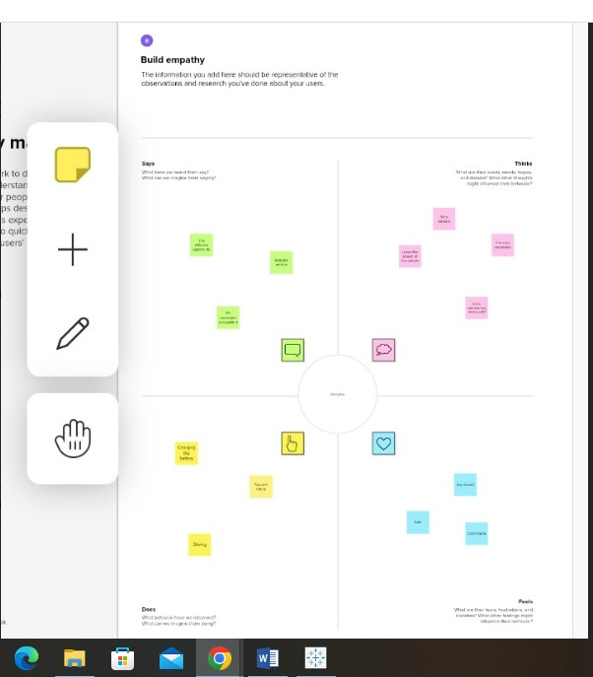

* **IDEATION & BRAINSTROMING MAP**

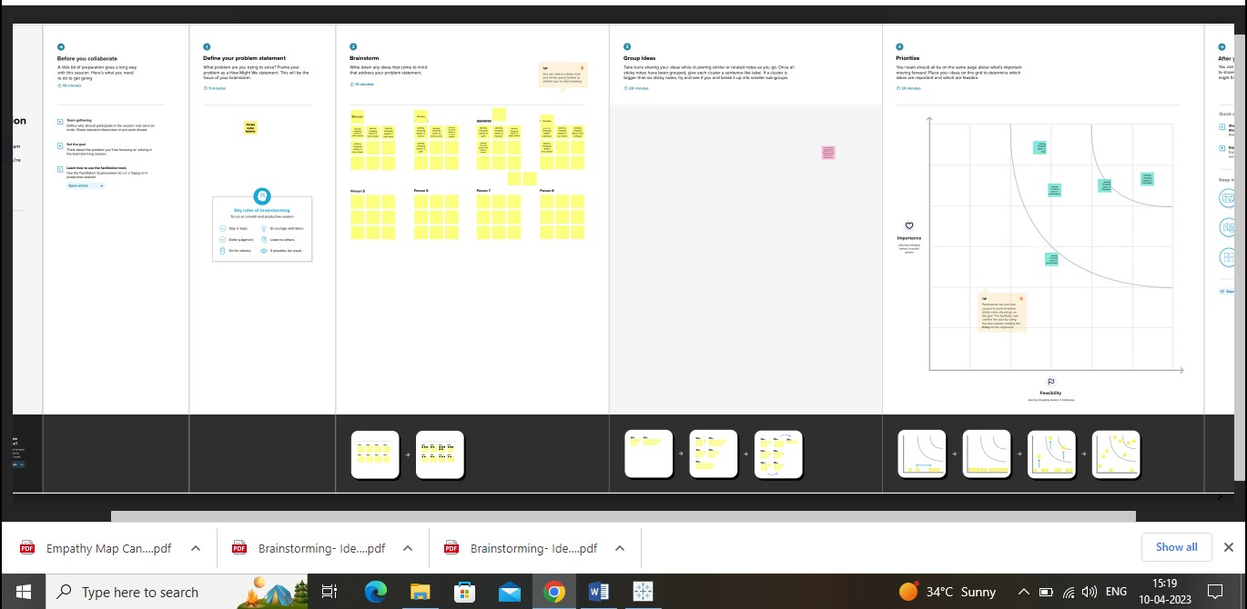

* **RESULT**

